**mU Mesh Editor**

**User Manual**

August 2014

# Start Extension

mU Mesh Editor Panel can be opened through Window->mU Mesh Editor Panel. Once the panel is opened, GameObjects with MeshFilter component in scene view can be processed by this extension.

# Main Window

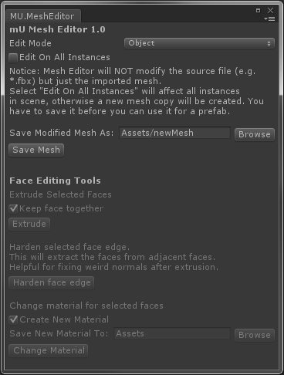

Figure Main Window

## Edit Mode

mU Mesh Editor provides 4 editing modes: Object, Face, Edge and Vertex. You can switch between these modes by choosing under the drop-down menu or right click on scene view and drag mouse onto the desired editing mode on the marking menu. You have to select an object before switching editing mode.

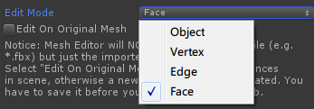

Figure Switch Edit Mode Using Drop-Down Menu

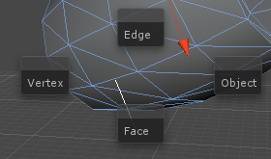

Figure Switch Edit Mode Using Marking Menu

**Edit On Original Mesh**

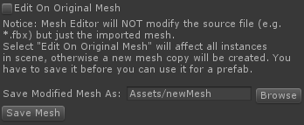

Figure Edit On Original Mesh

If selected, mU Mesh Editor will edit the shared mesh between all mesh instance, including the imported mesh and prefab (but not on the model source file like *.obj , *.fbx etc.)

Otherwise, a separated mesh copy will be created, and only the gameObject being edited will be affected. You have to save this mesh to disk before you can use it to create a prefab, or it'll be empty after instantiation. You can change saving path by typing in textfield or browsing. The containing folder has to be within Assets folder of this project.

Face Editing Tool will be introduced in later chapter.

# Toolbar



Move Tool

Rotate Tool

Scale Tool

**Selection**

To select a vertex/edge/face, click on it and it will be highlighted. Hold "Shift" to select multiple vertex/edge/face. Drag a rectangle on scene view to select all vertex/edge/face within the rectangle area. Press "Q" to enter selection mode without display the handles.

**Move**

To enter moving mode, Press "W" or click on Move Tool icon on toolbar. A moving handle will show up in scene view. You can move elements by dragging the handles around.

**Moving Coordinates:**



Figure Move Tool Option

Local: Using Object's local coordinates

World: Using World coordinates

Average Normal: Using the average face normal as the Y direction. (Only available under face editing mode)

**Rotate**

To enter rotating mode, Press "E" or click on Rotate Tool icon on toolbar. A rotation handle will show up in scene view. You can rotate elements by rotating the handles.

**Rotation Coordinates:**



Figure Rotate Tool Option

Local: Using Object's local coordinates.

**Scale**

To enter scaling mode, Press "R" or click on Scale Tool icon on toolbar. A scaling handle will show up in scene view. You can scale face by dragging the handles.

**Scaling Coordinates:**



Figure Scale Tool Option

Local: Using Object's local coordinates

World: Using World coordinates

Average Normal: Using the average face normal as the Y direction. (Only available under face editing mode)

**Undo**

The Undo function has been integrated with Unity Undo. You can undo your operations by selecting Edit->Undo or pressing hotkey (Ctrl-z or cmd-z). However, there’re certain limitations: 10 most recent operations (move, rotate, scale, extrusion, harden edge, change material and face removal) will be recorded. Redo is not supported yet, and if you try to redo anything it’ll will have unexpected results. **YOU HAVE TO QUIT MU MESH EDITOR BEFORE SAVING THE SCENE OR THESE UNDO RECORDS WILL CAUSE MESH LEAK!**

# Editing Mode

### Object

Under Object mode, it does nothing specifically. Unity itself will handle all your operations as usual, mU Mesh Editor will not intercept any action.

### Vertex

Under vertex mode, you can edit vertices on a selected mesh. mU Mesh Editor supports single/multiple vertex editing by tools provided on toolbar.

### Edge

Under edge mode, you can edit edges on a selected mesh. mU Mesh Editor supports single/multiple edge editing by tools provided on toolbar.

### Face

Under face mode, you can edit faces on a selected mesh. mU Mesh Editor supports single/multiple face editing by tools provided on toolbar.

In addition, MU Mesh Editor provides some other face editing tools on main window. These tools will be grayed out unless you have at least one face selected.

**Face Editing Tools:**

**Extrude:**



Figure Extrude Option

Keep Face Together: If selected, adjacent faces will be extruded together and move towards the same direction. Otherwise each face will be extruded separately towards its own normal direction.

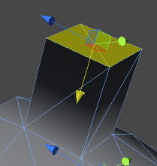

Figure Extruded Faces

**Harden Face Edge:**

Unity hardens edge by separating shared vertex and assign different normals. This might cause visual glitch after an extrusion. Use this if you have unwanted soft edges or weird normals on the mesh.

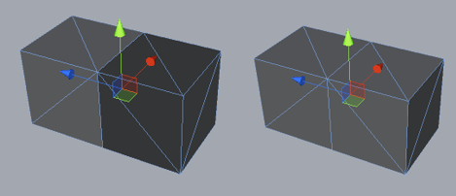

Figure Left: Incorrect Normal after Extrusion. Right: Fixed Hard Edge Normals

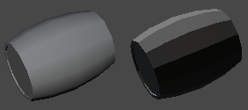

Figure Left: Soft Edge. Right: Hard Edge

**Delete:**

Press “delete” key to remove currently selected faces.

**Change Face Materials (experimental):**

Create New Material:



Create and assign a new material to selected faces. The default shader is "Diffuse". You can change saving path by typing in textfield or browsing. The containing folder has to be within Assets folder of this project.

Not Create New Material:



Select and assign a existing material to selected faces.

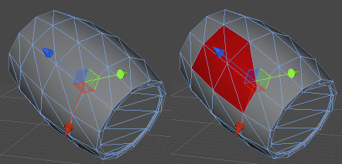

Figure Left: Before Changing Material. Right: After Changing Material

# Changelogs

2014-08-12 Version 1.11

- Performance Improvement

- Fixed compatibility issue between Change Face Material/Submesh and other face editing tool

- Fixed wrong scaling direction in world and normal coordinate

2014-08-07 Version 1.1

- Vertex/edge/face editing

- Move/scale/rotate operation

- Face extrude/harden edge/change material/delete

- Save mesh to disk